Homework Assignment 6

Tyler Paulley

11/22/2016

**Testing the code that finds the longest common subsequence between two sequences:**

**Example with subsequent characters:**

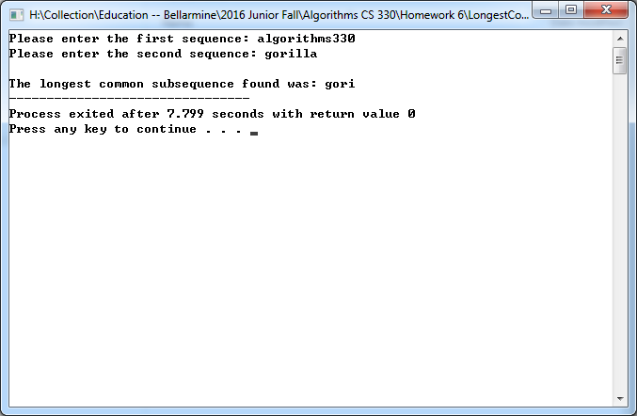

**Example with non-subsequent characters:**

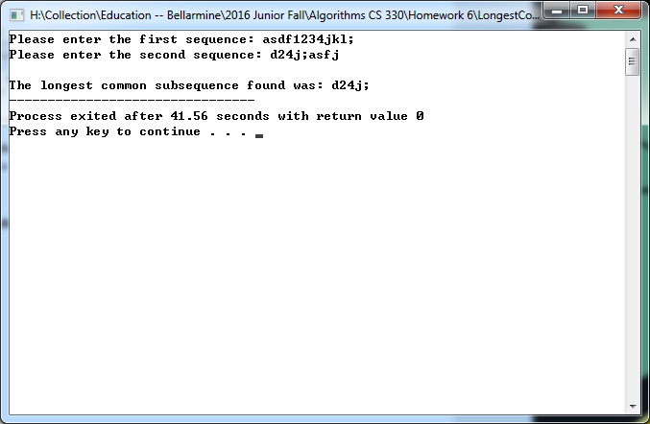

**Example with no matching subsequences:**

